**PROJECT EULER SUMS**

1) If we list all the natural numbers below 10 that are multiples of 3 or 5, we get 3, 5, 6 and 9. The sum of these multiples is 23.

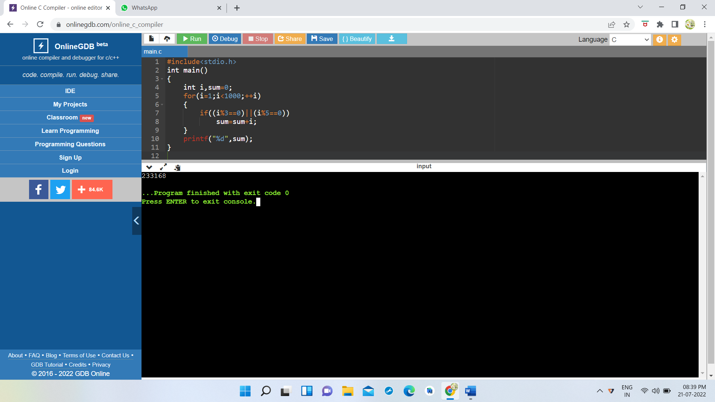Find the sum of all the multiples of 3 or 5 below 1000.

2) Each new term in the Fibonacci sequence is generated by adding the previous two terms. By starting with 1 and 2, the first 10 terms will be:

1, 2, 3, 5, 8, 13, 21, 34, 55, 89, ...

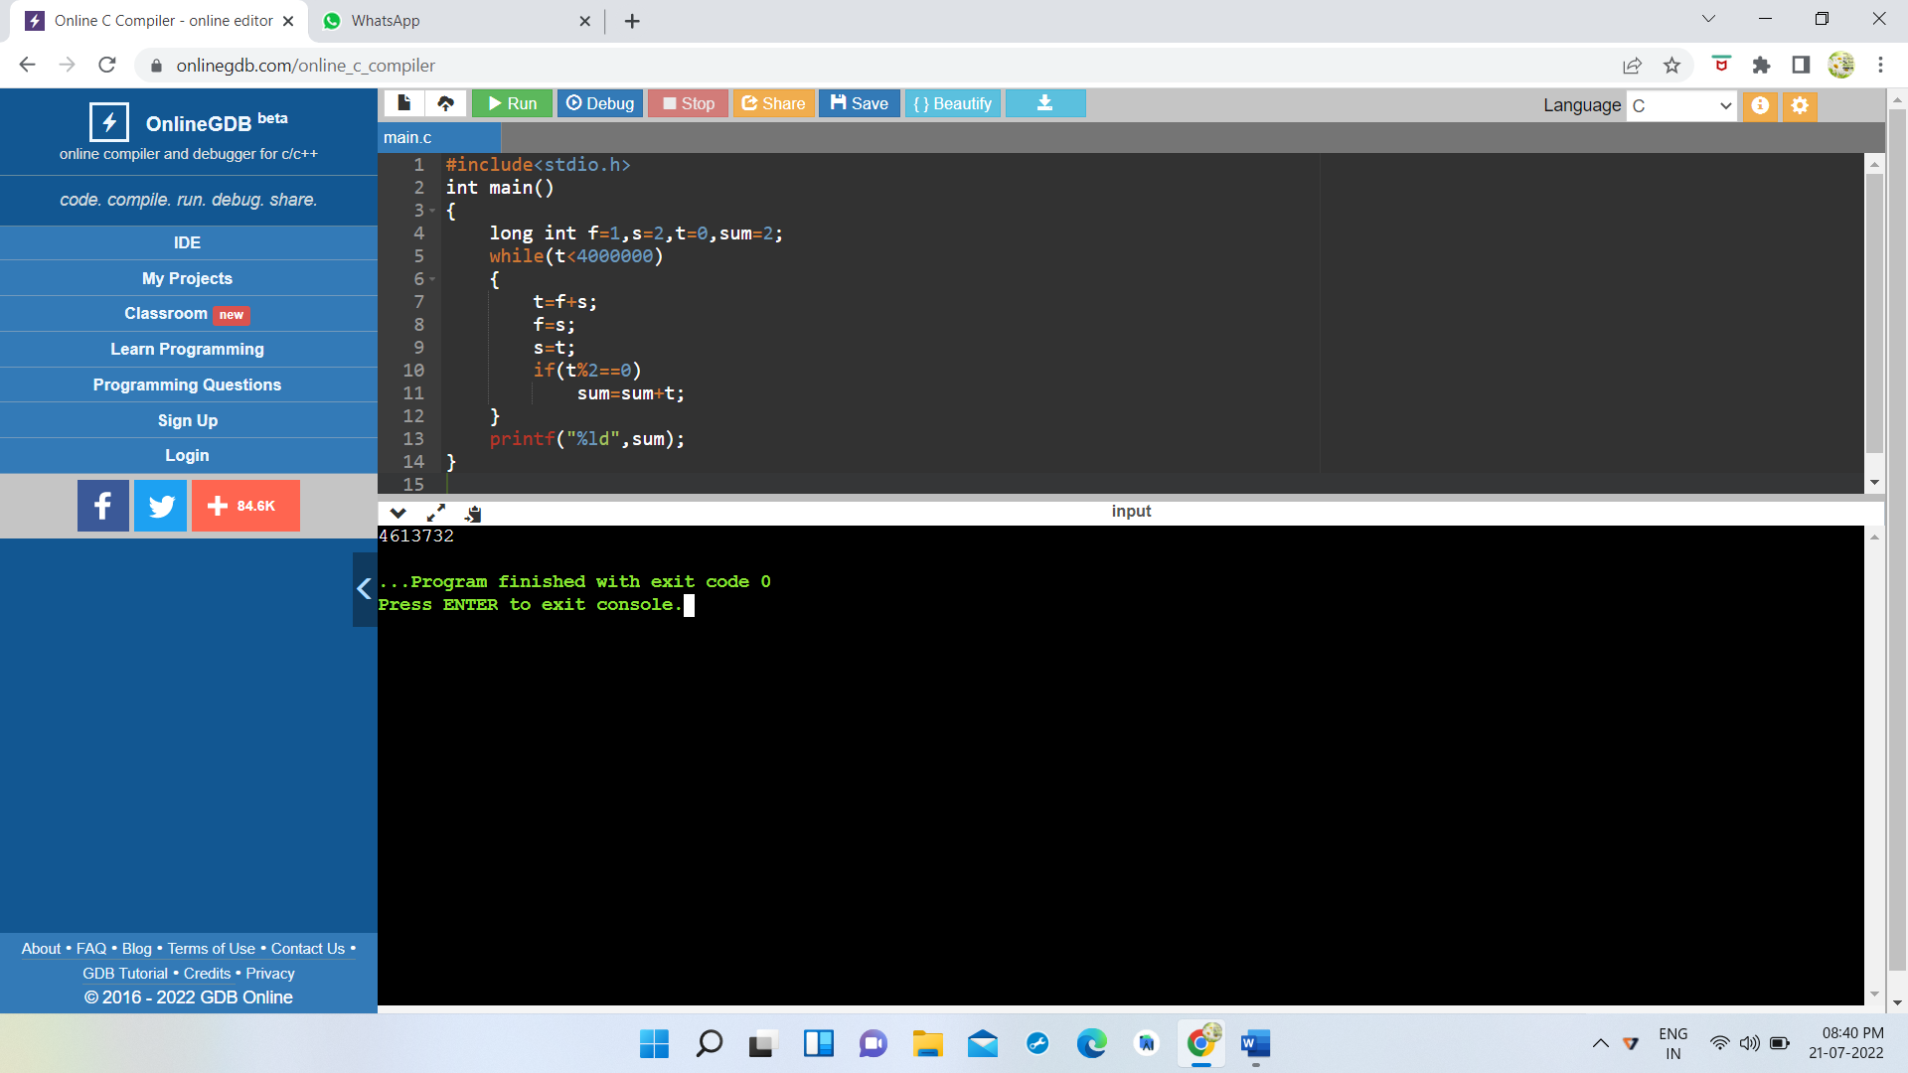By considering the terms in the Fibonacci sequence whose values do not exceed four million, find the sum of the even-valued terms.

3) The prime factors of 13195 are 5, 7, 13 and 29.What is the largest prime factor of the number 600851475143 ?

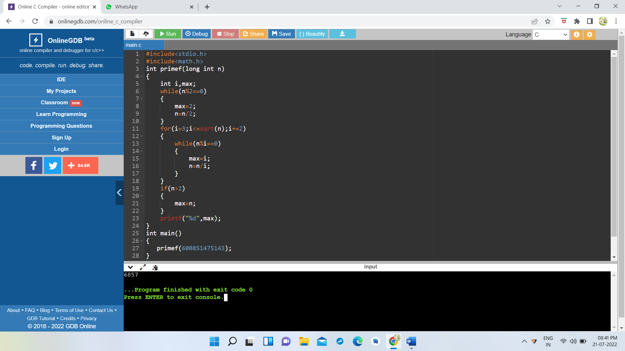

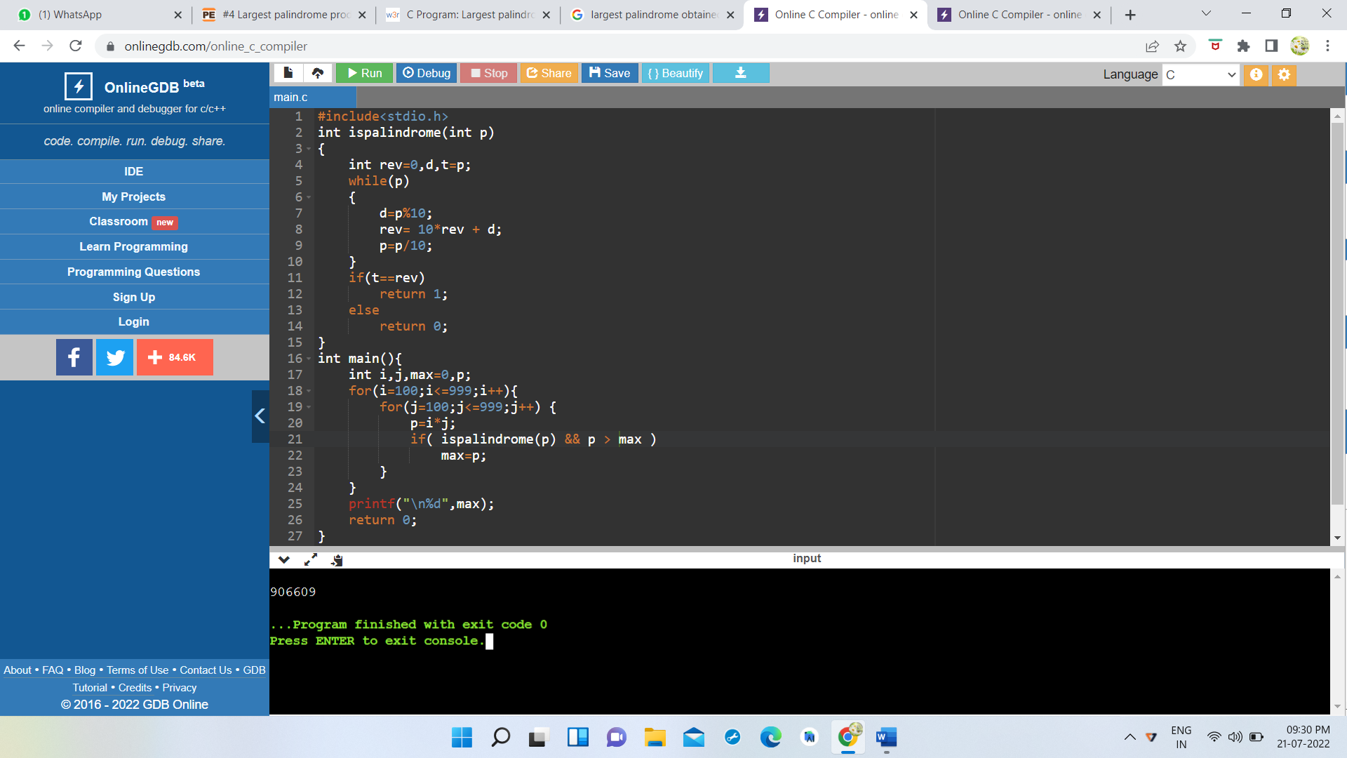4)A palindromic number reads the same both ways. The largest palindrome made from the product of two 2-digit numbers is 9009 = 91 × 99.Find the largest palindrome made from the product of two 3-digit numbers.

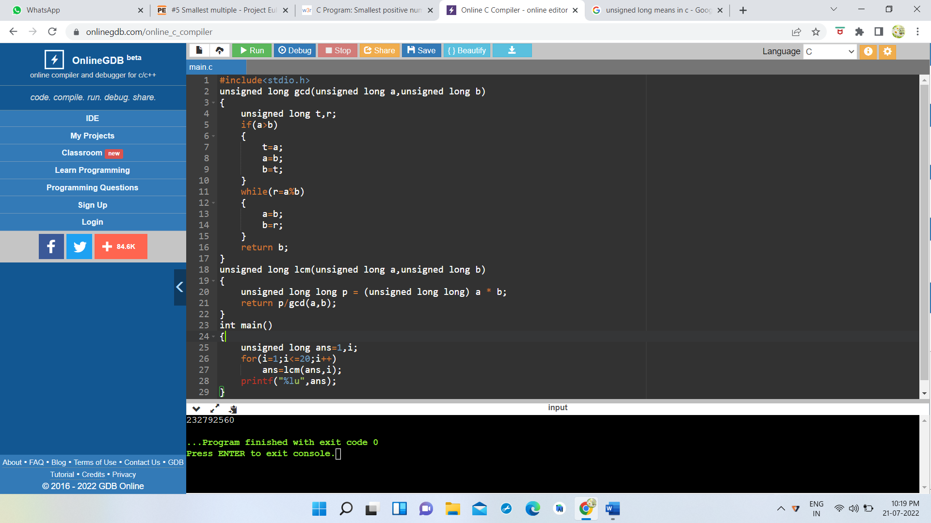5)2520 is the smallest number that can be divided by each of the numbers from 1 to 10 without any remainder. What is the smallest positive number that is *evenly divisible* by all of the numbers from 1 to 20?

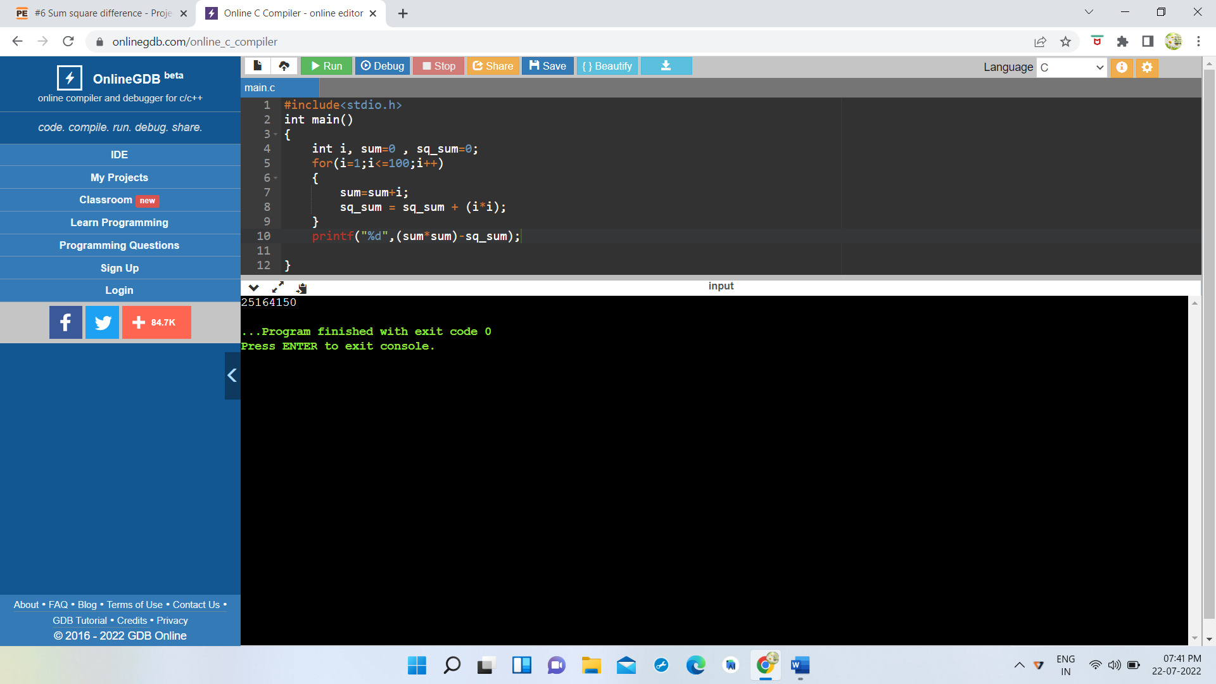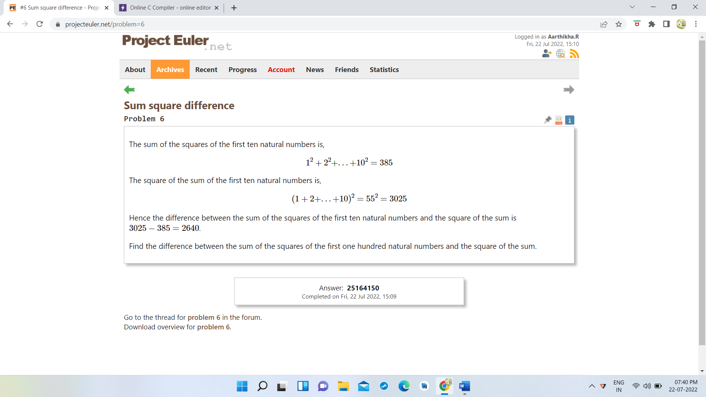6)

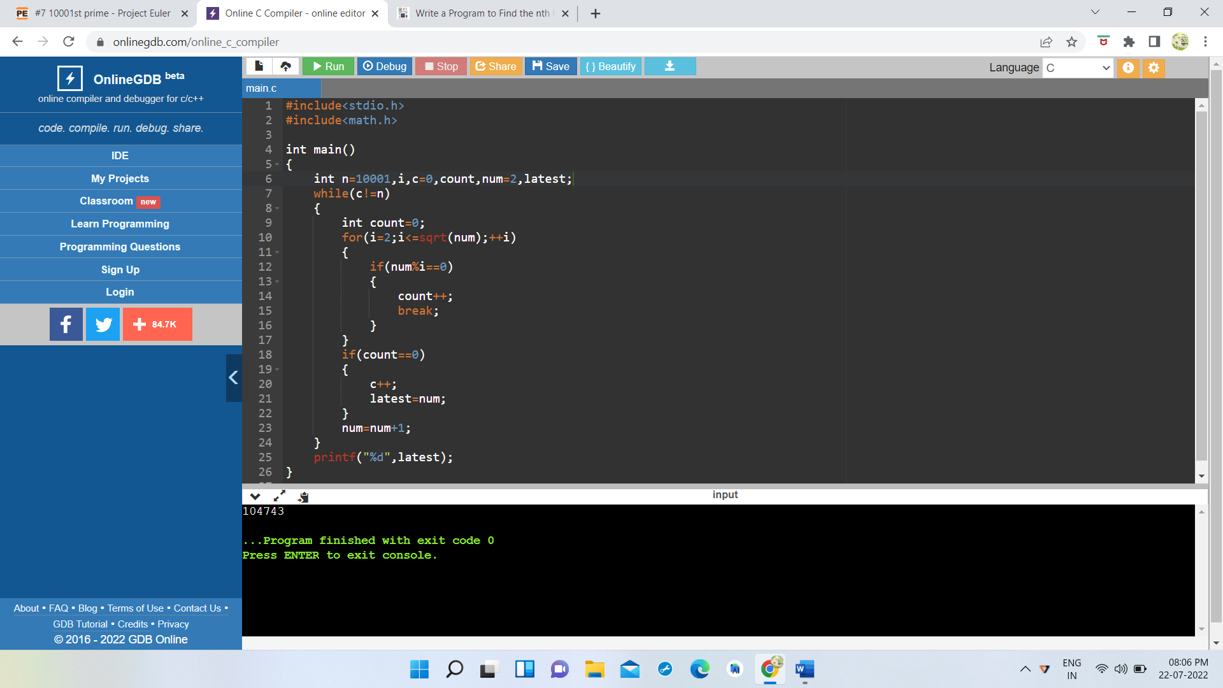7) By listing the first six prime numbers: 2, 3, 5, 7, 11, and 13, we can see that the 6th prime is 13. What is the 10001st prime number?

9) A Pythagorean triplet is a set of three natural numbers, *a* < *b* < *c*, for which,

*a*2 + *b*2 = *c*2

For example, 32 + 42 = 9 + 16 = 25 = 52.

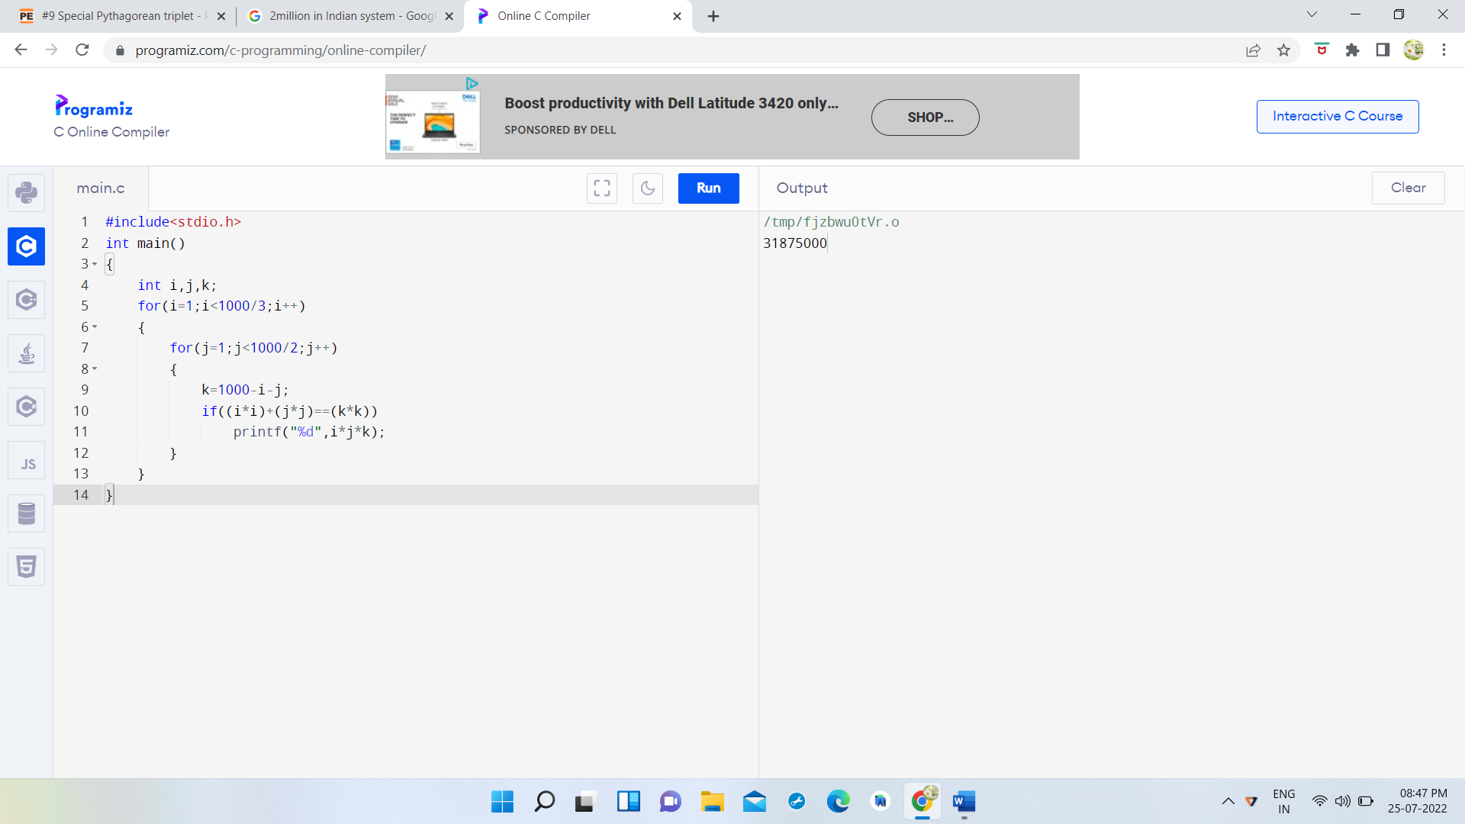There exists exactly one Pythagorean triplet for which *a* + *b* + *c* = 1000.  
Find the product *abc*.

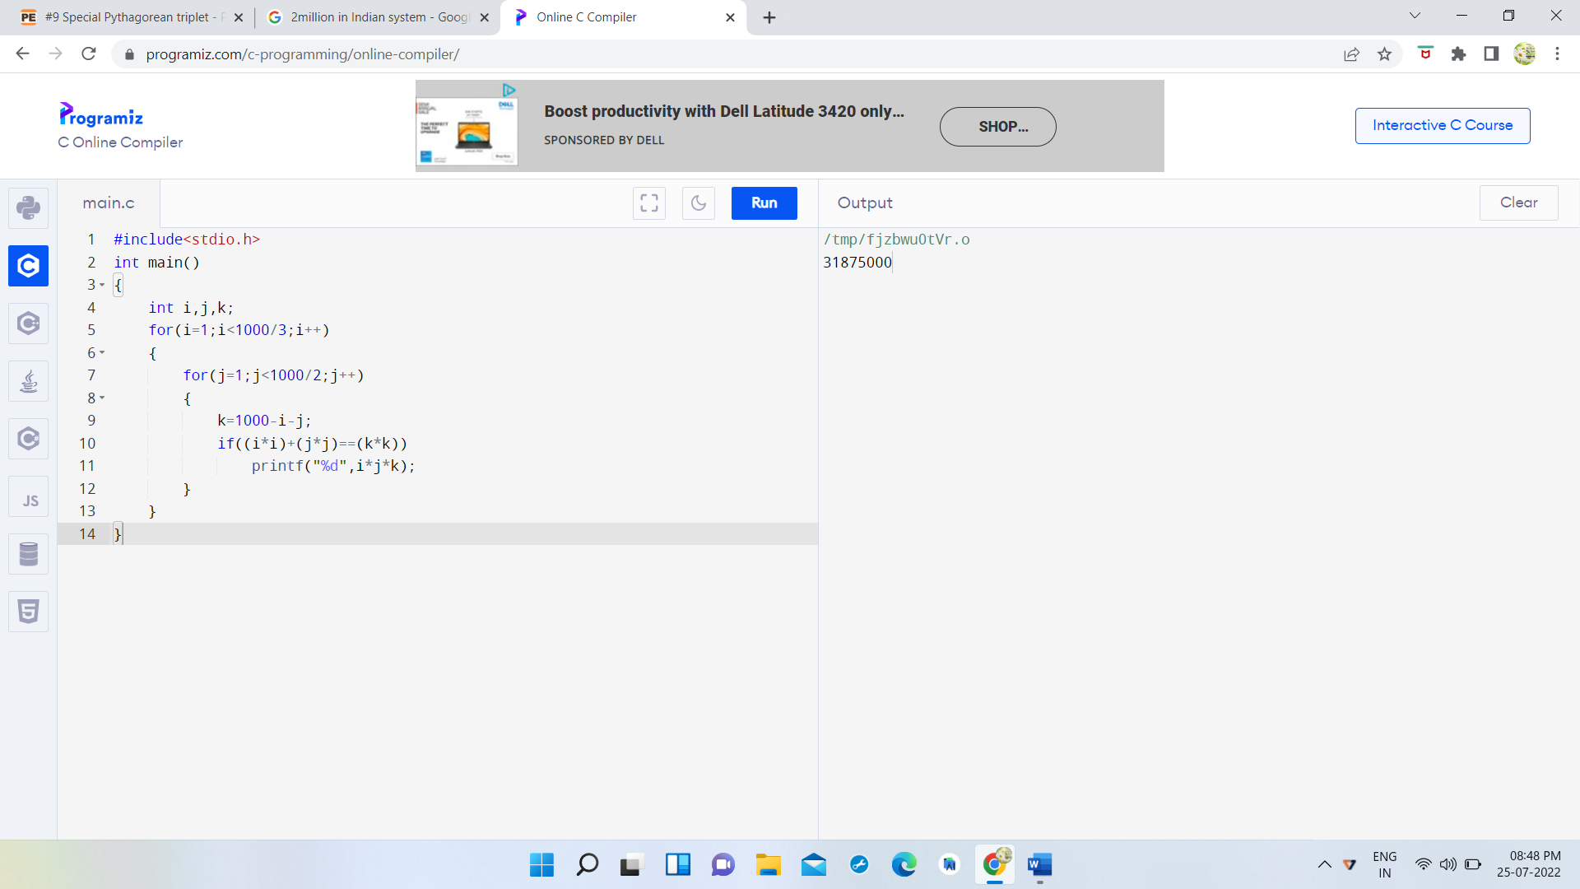Output:

10)The sum of the primes below 10 is 2 + 3 + 5 + 7 = 17.

Find the sum of all the primes below two million.

#include<stdio.h>

#include<math.h>

int isprime(int num)

{

int f=0;

for(int i=2;i<=sqrt(num);i++)

{

if(num%i==0)

{

f=1;

return 0;

break;

}

}

if(f==0)

return 1;

}

int main()

{

int num=2;

long sum=0;

while(num<2000000)

{

if(isprime(num)==1)

sum=sum+num;

num++;

}

printf("%ld",sum);

}

Output:

142913828922